

Name of Applicant
/Contact person : XXXX
Name of Concern : XXX
Office Address : XXXX
Phone : - XXXX

Appointment Fixed : 3:30 PM, Date of Visit: 26-04-2025
Structure of Loan : Purpose of the Loan is Business Expansion.
Loan Amount : Rs. 80,00,000/-

No. of Visit : This is the first visit to the applicant.

Person Met : Mr. K. Chandra Sekhar
The following data and explanation are based on the verbal information provided to us during the course of the visit.

About the Applicant:

Applicant family consists of 03 members including Him.

About the Business:

- In the year 1995, applicant started business with the name of M/s. XXXX at Hyderabad.
- It is a Sole Proprietorship Concern and the applicant is the proprietor.
- All the business activities are managed by applicant only.
- Nature of business is Sale and Service of Refrigerators and Air Conditioners.
- He sells all ranges of Refrigerators and Air Conditioners in this Premise.
- And he has providing services for these goods.
- He purchases stock from local distributors.
- His customers are general public and schools and colleges, restaurants, industries.
- He charges Rs. 300/- to Rs. 1,000/- repair amount depends upon work.
- He has maintaining around Rs. 5,00,000/- worth of stock in this Premise.
- He is running this business in rented premise and he pays rent amount of Rs. 30,000/- per month.
- Applicant is mostly depends on service oriented only during summer seasons he also does sales.
- Applicant is authorized service provider for LG products apart from that he also does the other company products too.
- There are 10 workers working in this Business under him and he pays salaries amount of Rs. 2,00,000/- per month.
- Both cash and bank transactions are noticed.
- Good level of stock seen at premise.

He wants to avail this loan for the purpose of Business Development.

Turnover and net profit details for last one year audited financials.

AY | Turnover | Net Profit | Net margin (%)
-

Documents Observed:

- GST Registration Certificate
- IT Returns
- Bank Statements

Automation Level:

- Good level of stock Business activity seen at time of visit.

Customers:
- Mr. Name – Number

Purchase:

- Mr. Name – Number

Margins:

- As per applicant, they get around 15.37% as a net margin in this business.

Employees:

- 10 workers are working under the applicant.

ASSETS:

- -

LOANS:

Financial Institution | Loan Amount | Nature of Loan | EMI
IKF Finance | 40,00,000 | Business Loan | 66,000

END USE:

- Applicant wants to avail this loan for the purpose of Business Development.

SECURITY OFFERED

- Own House Property at Hyderabad.

ADDRESS: -

Balanagar, Hyderabad.

OBSERVATION:
- Both cash and bank transactions are noticed.
- He has around 35 years of experience in this field.

Concerns:
- Dealership certificate was not provided
- GST returns are not provided.

OTHER BUSINESS/INCOME: -
- -

Disclaimer Clause:
This report (including any attachments) has been prepared on the basis of verbal information and documents provided by the person contacted. Hero Fincorp will be solely responsible for any actions taken on this report and any liabilities directly or indirectly accruing from such actions. Efficient Services will not be held liable in any case.

Place: - Hyderabad.
Date: - 26-04-2025

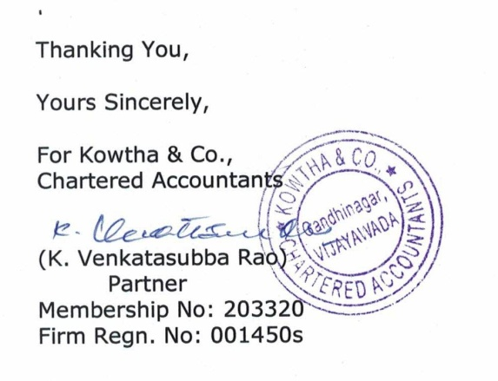

Photos:

